**Data Warehouse**  
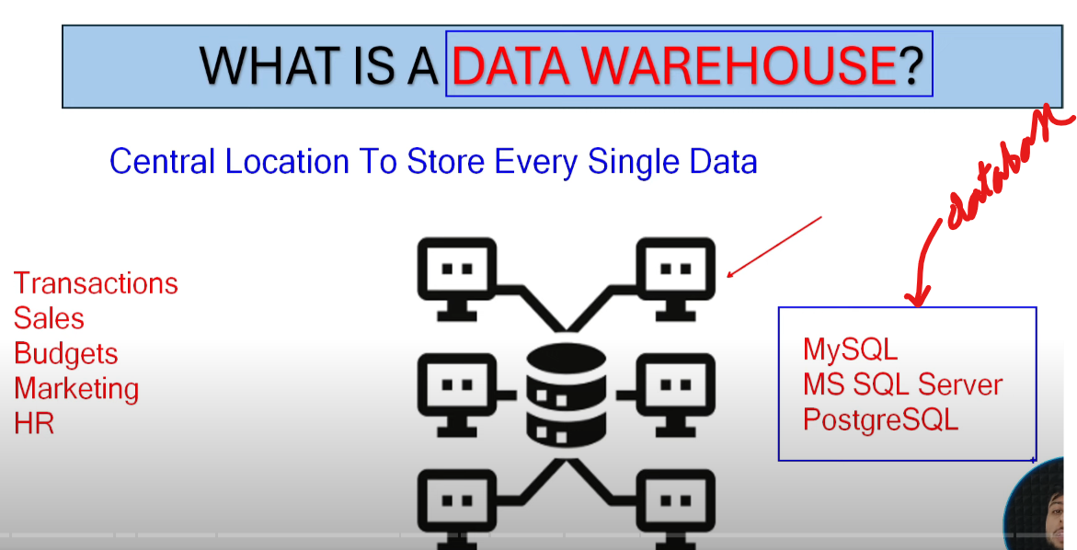  
DWH is a central repository of an organisation to store all the data eg. data regarding transactions, budgets, etc.  
MySQL, PostgreSQL, etc there are all DBMS (Database Management Systems), we can also store datawarehouse in these databases.  
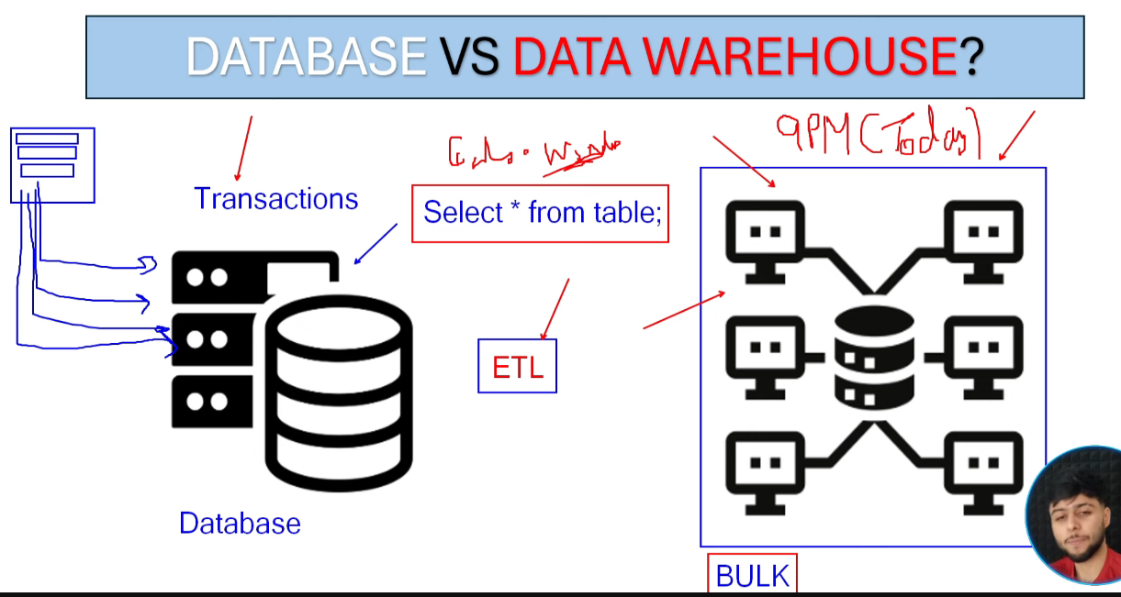  
DB and DWH both store data in tabular format.  
DB stores data in the form of transactions, near real time data.  
Now if we want to build Reports on top of DB, then the DB SQL engine will be busy interacting with source (cause insertion of data is happening in milliseconds), the load balance will not going to be maintained between reports and new data feed from source, it slows down the performance, refresh will also not function properly.  
Load the data in DWH from DB, in DWH the performance is better because we perform ETL while moving data from DB to DWH. We don’t apply transformation on the source side, we just pull the data in BULK from DB (let’s say daily 9 PM) on incremental fashion.  
DB is real time data whereas DWH is static data. So all the data folks can query data from DWH not DB. And also DWH is also moving to cloud(Delta Lake) as the volume of data is increasing exponentially.  
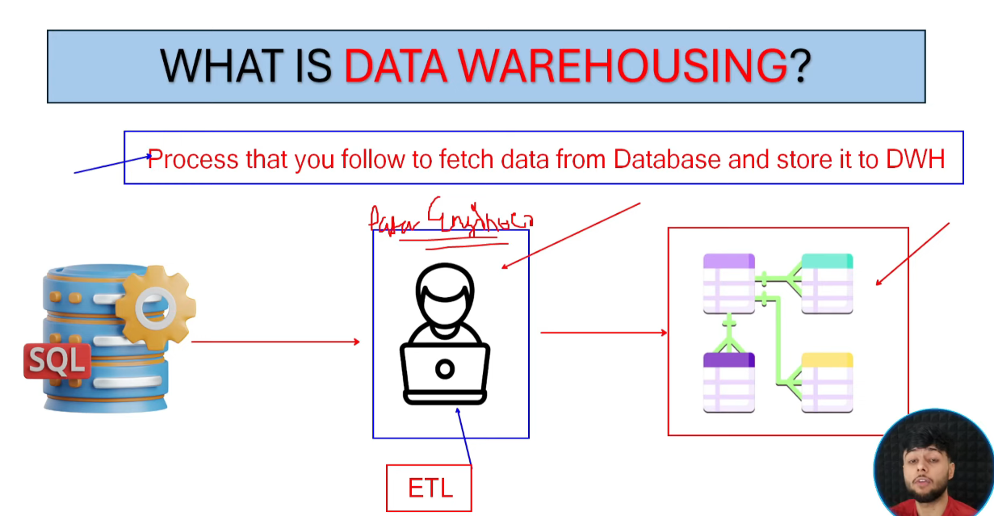   
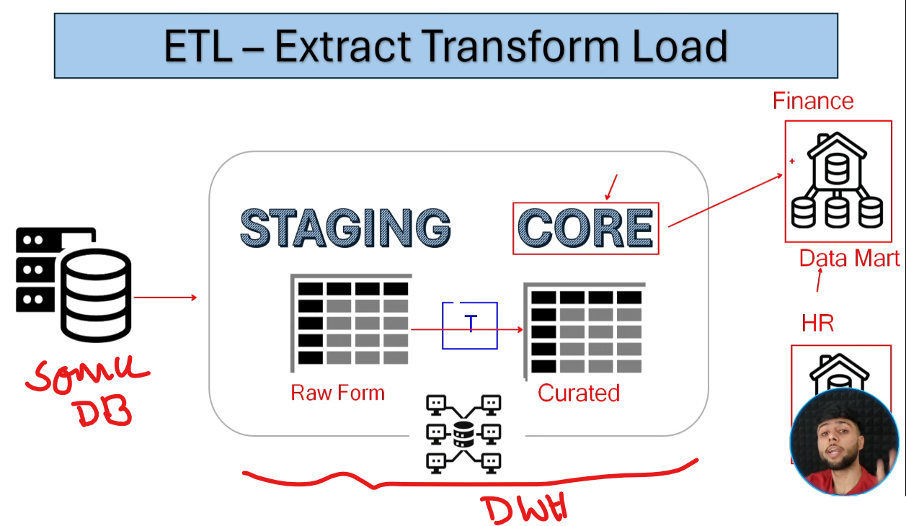  
Core layer is the business layer which is exposed to all the Data professionals. Curated data can be used to build Reports, Dashboards, Visualizations, ML Model  
  
Data Mart 🡪 subset of DWH (eg if DWH is holding data for the entire organisation then Data Mart holds data for specific domains like HR, Finance), so when we separate the database based on the business requirements.  
  
  
  
  
  
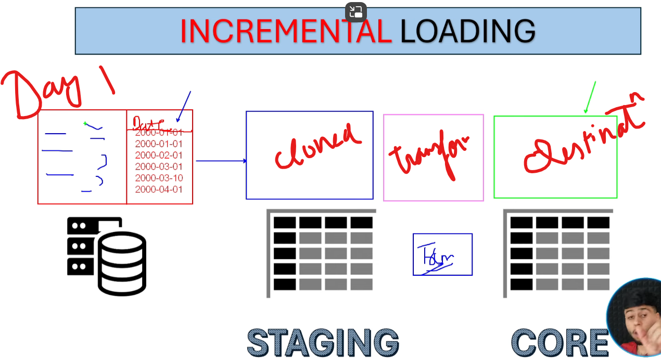  
Day 2, we have to ingest only new records, how we can do this? By performing CDC (Change Data Capture)🡪 in the historical load, we will keep the maximum date in a table and from next date we will read data only after that date  
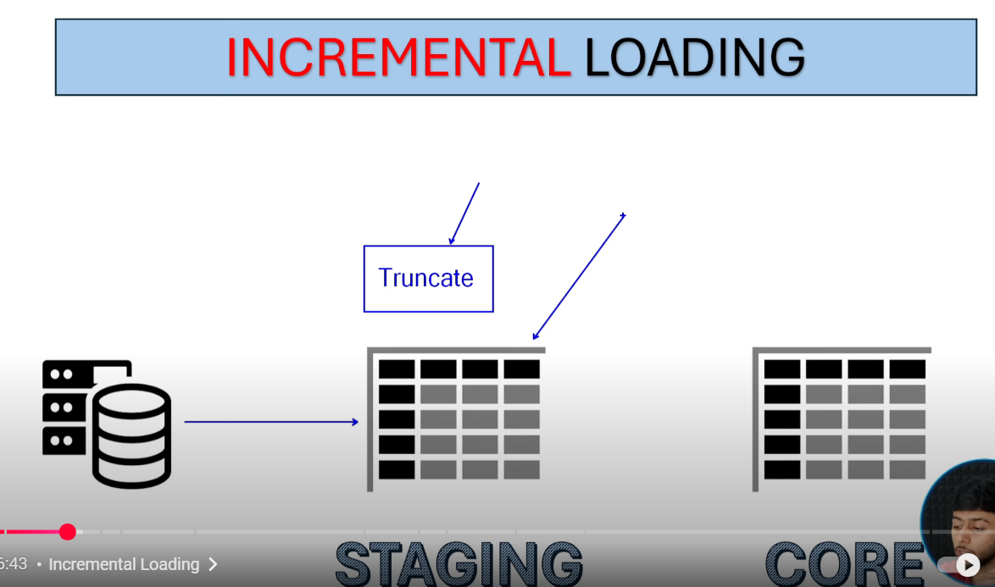  
In Staging, every time we truncate this layer, so that we can only pull the incremental data using CDC 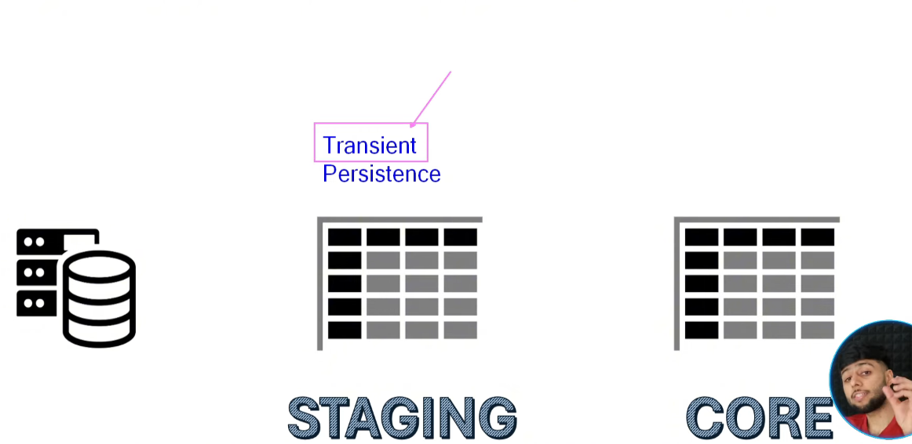Staging layer has 2 layers: 1) Transient 2) Persistence  
Transient : just Truncates the data   
Persistence : just keep the data  
Sometimes we use Transient sometimes Persistence based on requiremnets  
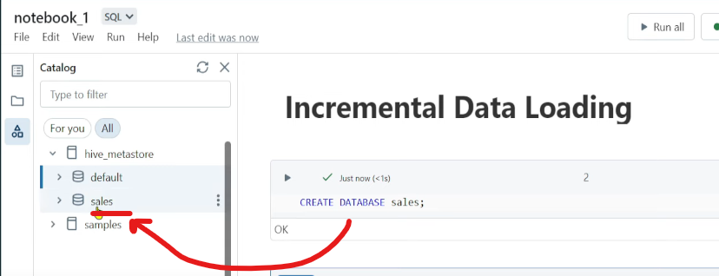  
  
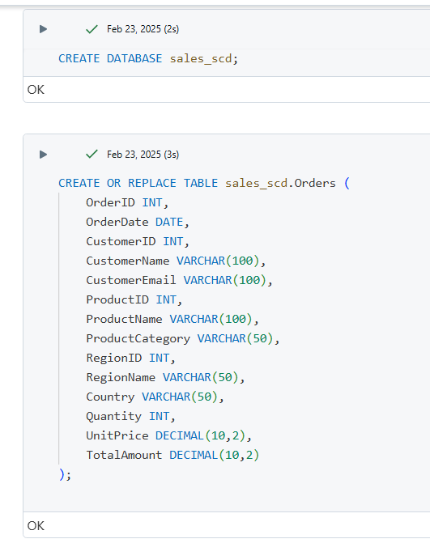 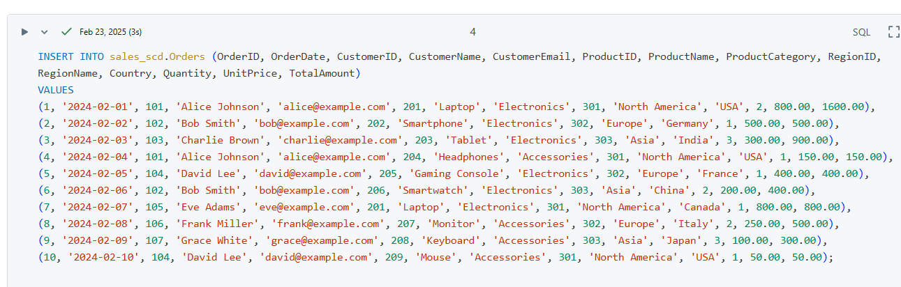  
So our table in DB is ready, now we will create DWH 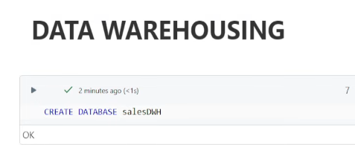   
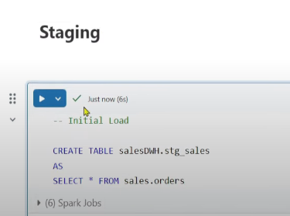  
Pushing data from DB to stg table of DWH  
   
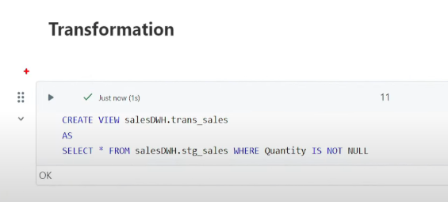   
Transformation is to consider Quantity with some value  
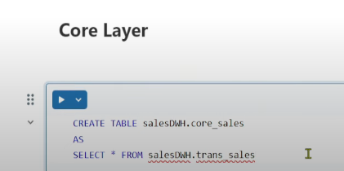  
Now insert some data in the DB table for incremental loading test  
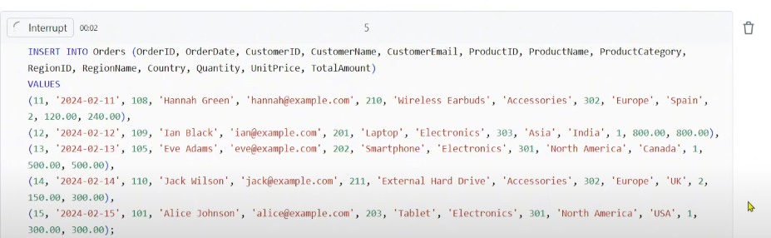 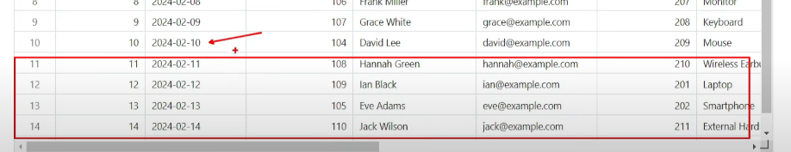 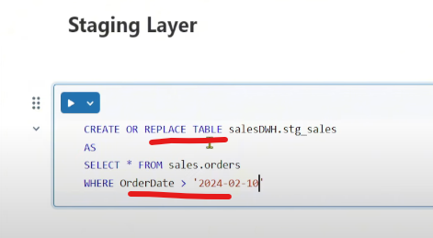Truncate logic has been used and also CDC implemented on Date  
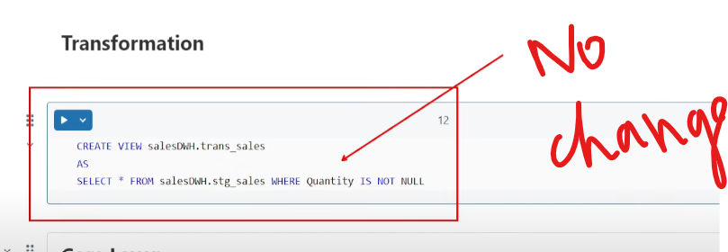  
But the entire Core Layer logic has to be changed (simply create a Table and then insert into the Table)   
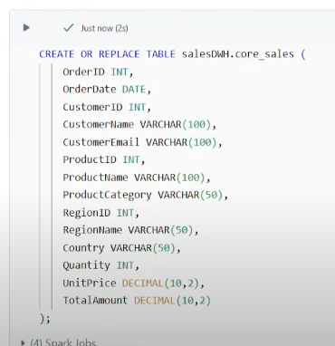 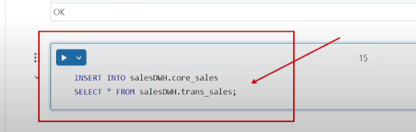

Data Modeling (Serving data to stakeholders)  
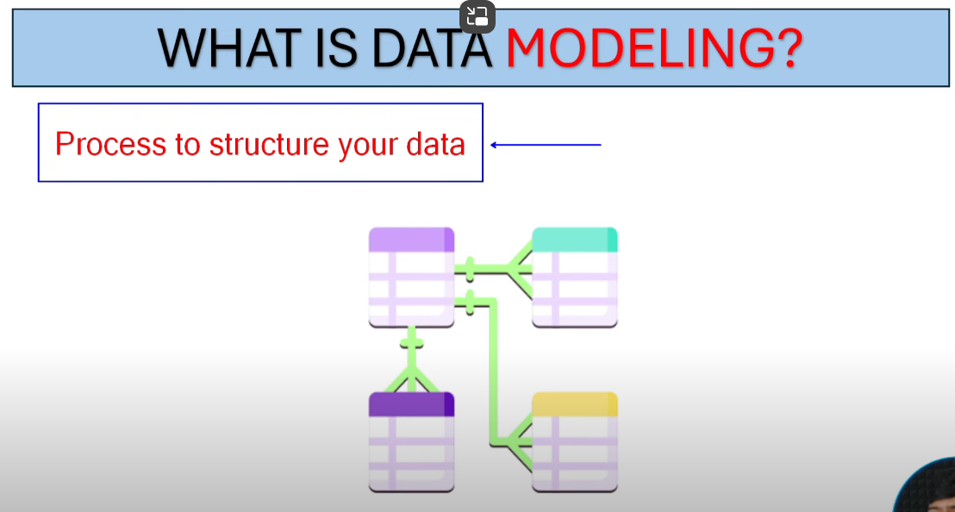  
To take data driven decisions, difficult to understand the data in the form of one big table, Data Modeling is necessary to store data efficiently without any redundancy, in order to save storage cost, we have to build data model  
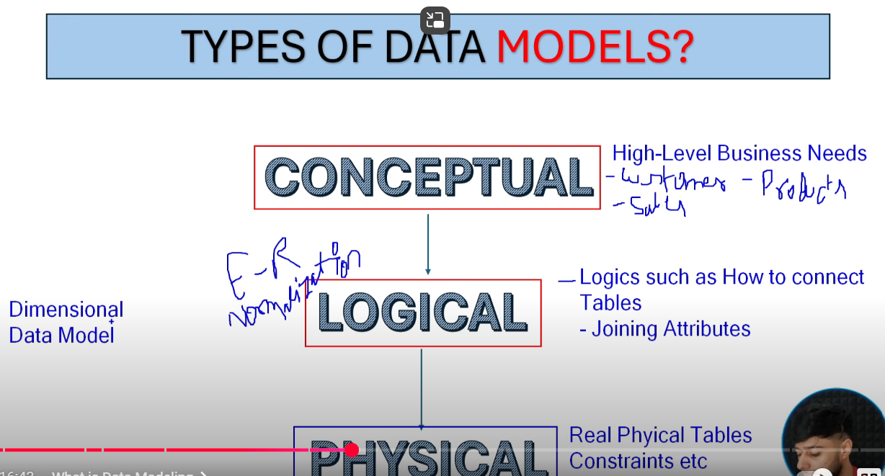  
1. Conceptual DM : High level understanding of business requiremnets i.e. identifying different tables  
2. Logical DM : One step beyond Conceptual DM, how the tables will be connected to each other/Joining keys/attributes. Here we see ER(Entity Relationship), normalization  
Data Engineers don’t use normalization but they use Dimensional Data Model  
3. Physical DM : Actual tables residing in db, constraints like Primary keys.

Dimensional DM  
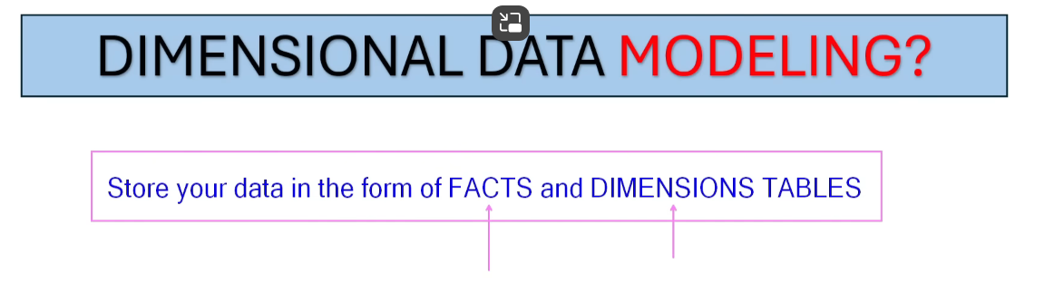  
Fact Table 🡪 available at the most granular level (no aggregations on Fact), Facts are numeric columns(Price, cost, revenue) along with keys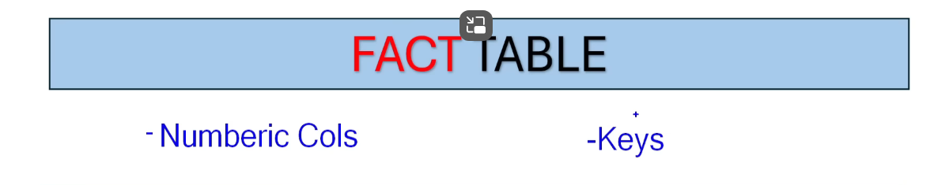  
Dimension Table: we cant store any numeric columns, it only holds the context of the table 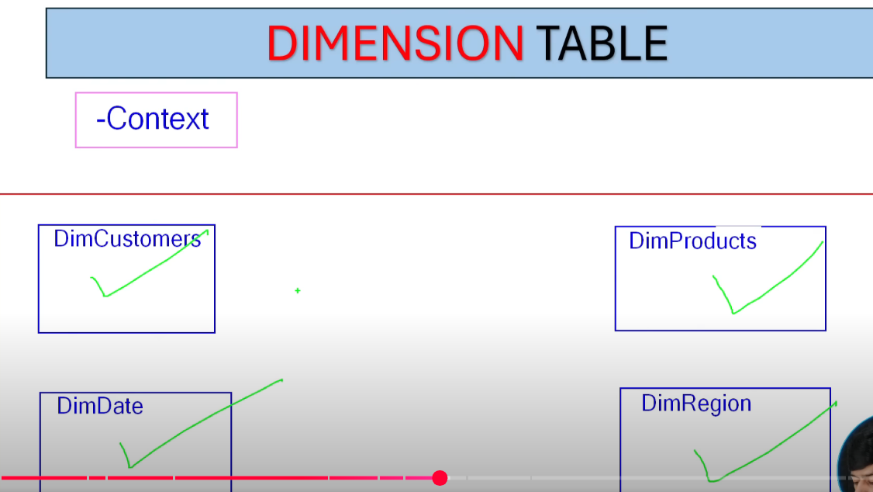 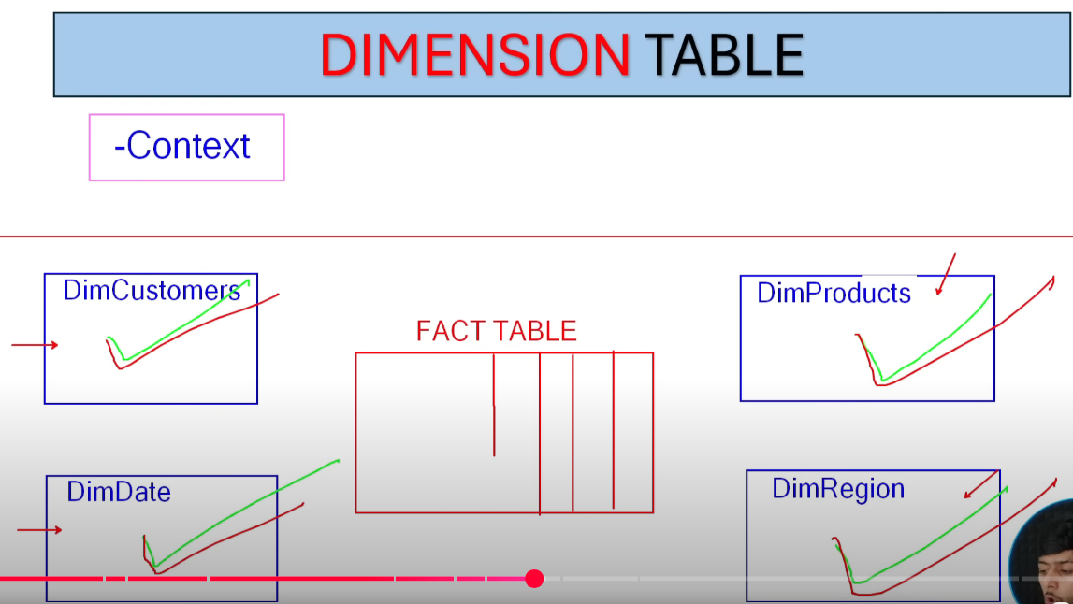  
Apply aggregations on the Context (in Dimension Tables), Numbers will be in Fact along with Foreign keys  
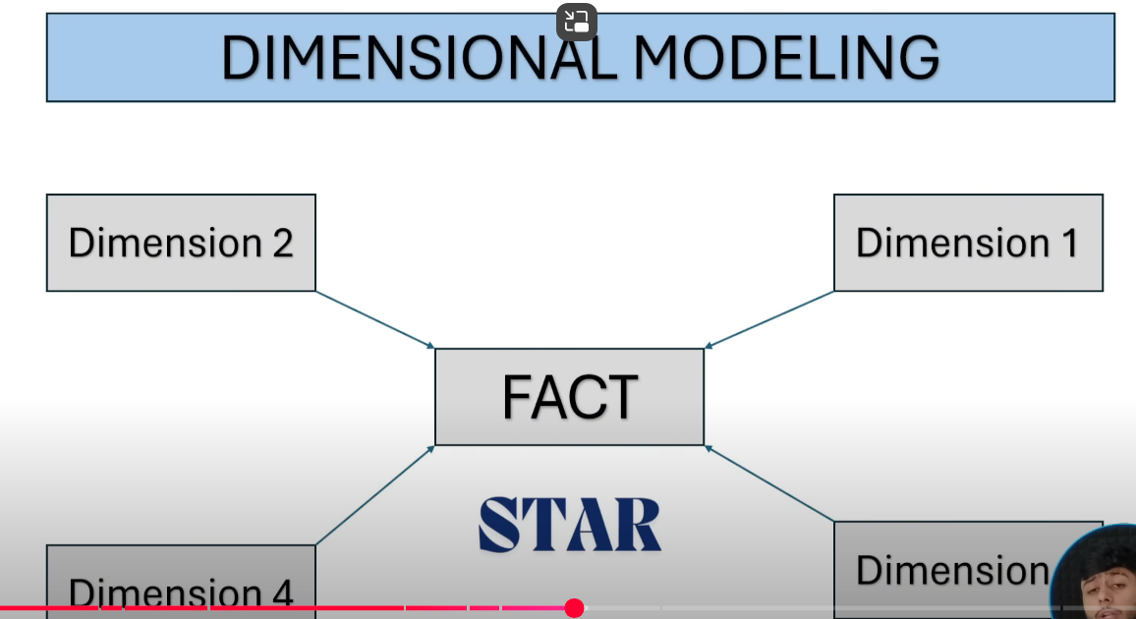  
Star Schema 🡪 1 Fact & multiple dimensions, no hierarchy between the Dimensions i.e. Dimension is directly attached to the Fact  
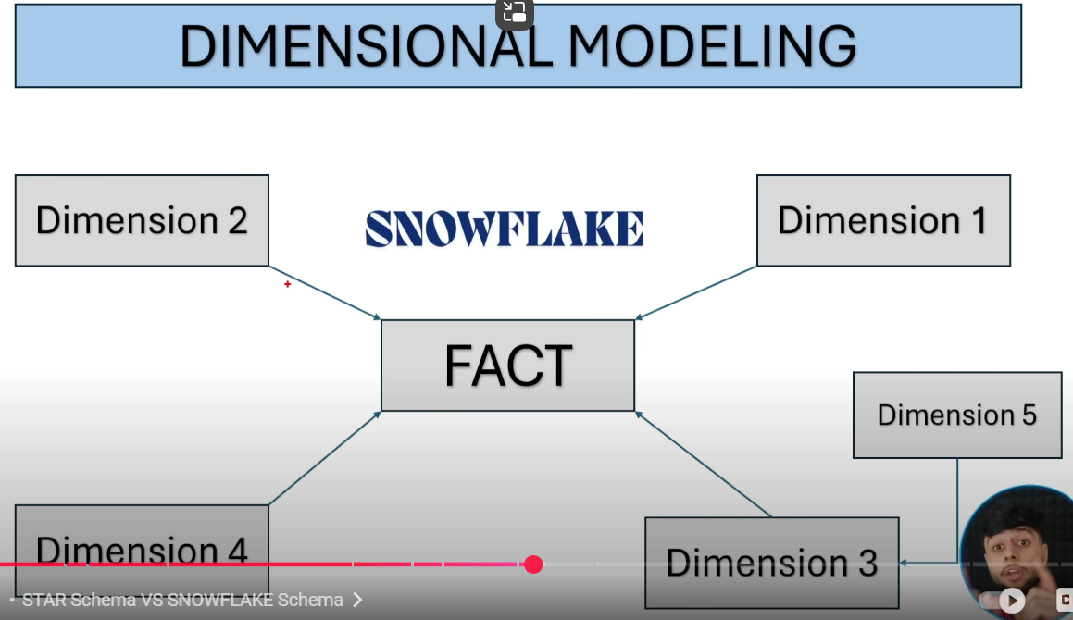  
Snowflake : Hierarchy among dimensions

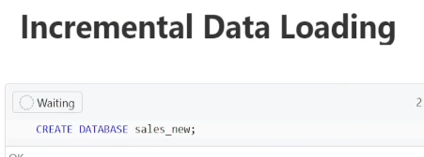 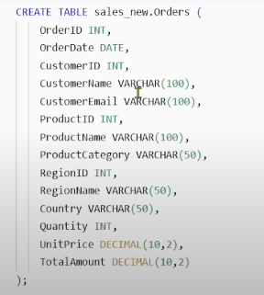Insert some data  
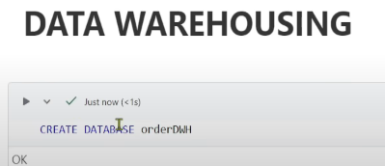 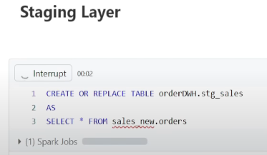 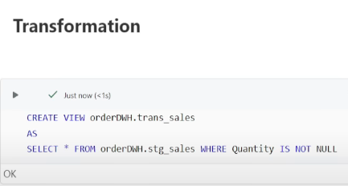  
Now lets do Data Modeling, since we have only one table, we will create Dimension tables from this table 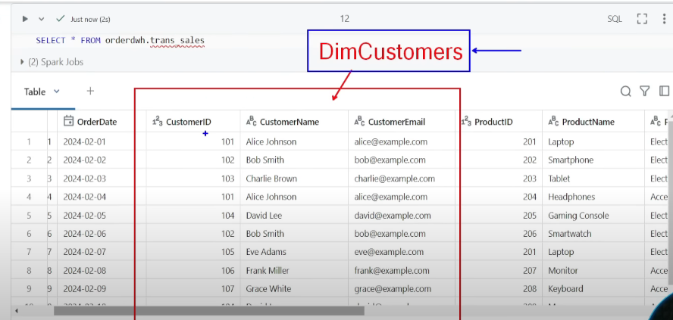  
We will join Fact and Dimension using Dimension Surrogate key (Pseudo key we create for joins) and since this table is containing transactions that means one customer can perform various transactions, have to use distinct while creating dimension. Fact and dimension tables are mostly in many to one relationship.  
Create Dimension tables first and then Fact table, because we have to create the dimension surrogate keys first then only we can map it to Fact table  
Dimension Surrogate key can be created using row_number or monotonically_increasing_id  
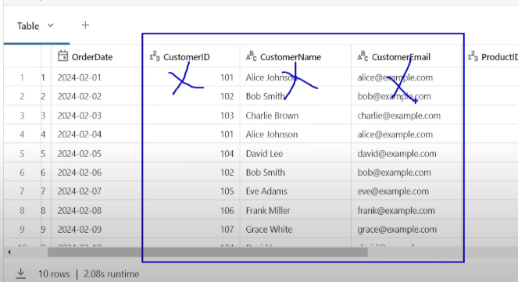these 3 columns will be removed from Fact table and will have Dimension Surrogate instead   
  
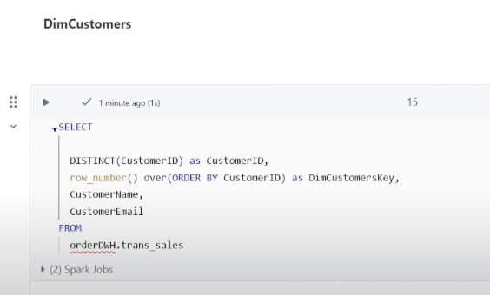 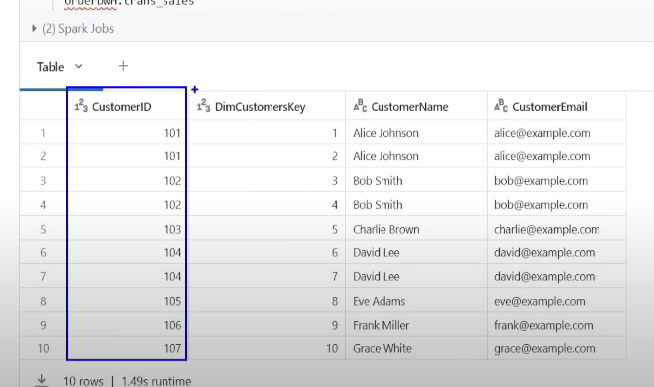It should have 7 records, but 10 records since DISTINCT and row_number are countering each other, lets use subquery 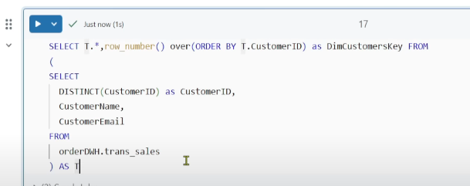  
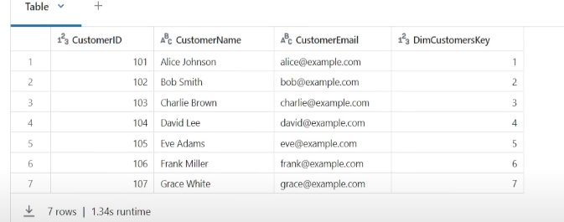   
Create a view on top of this query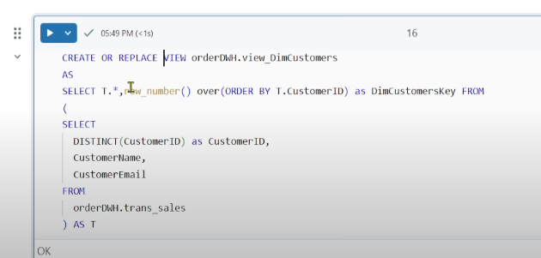 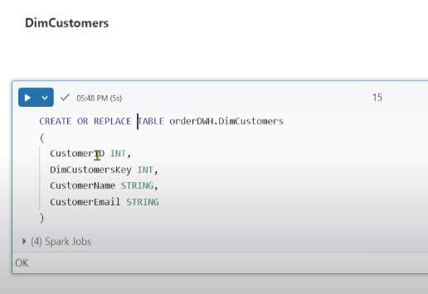 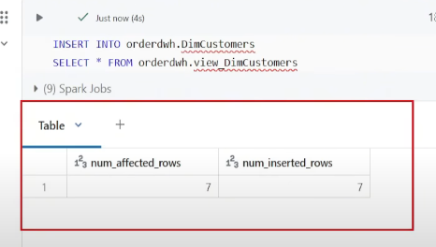  
  
Similarly for Product dimension  
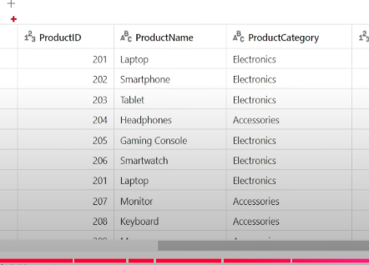  
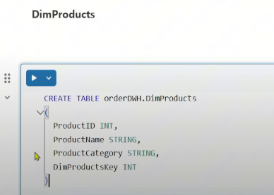 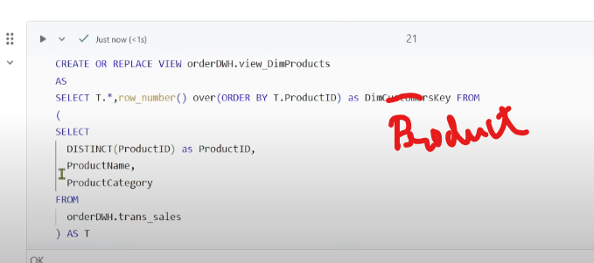 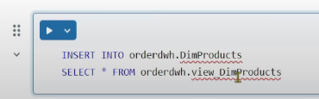 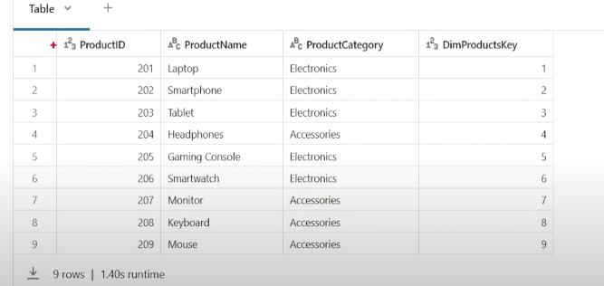

Similarly for Region dimension  
  
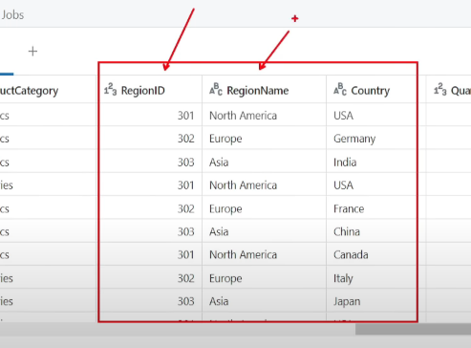 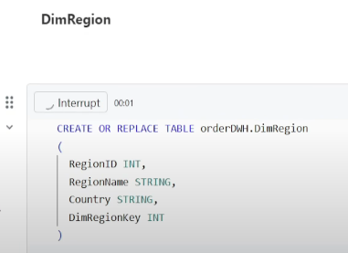 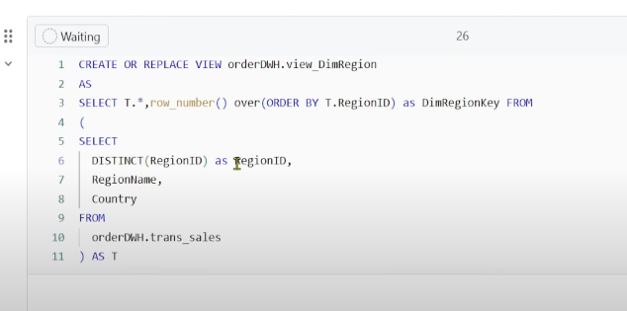 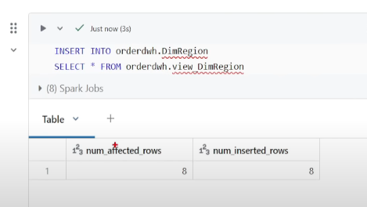

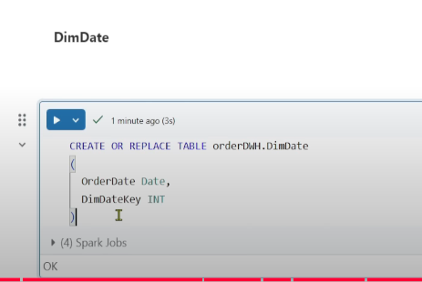 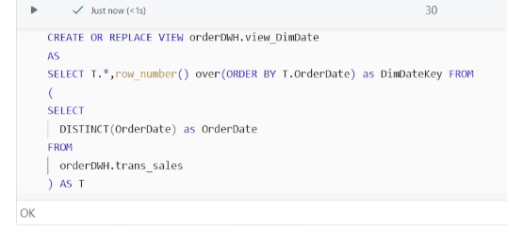 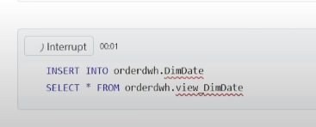  
OrderDate is Degenerate dimensions

We have created 4 dimension tables, now lets create Fact table  
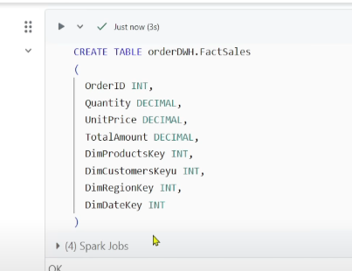  
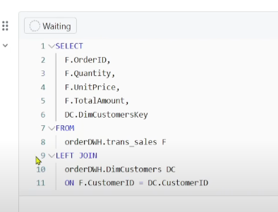 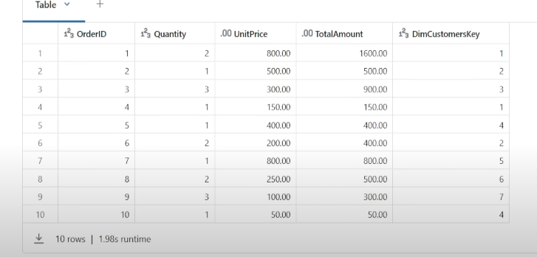  
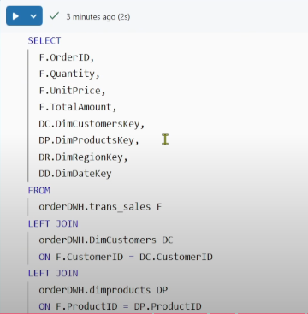 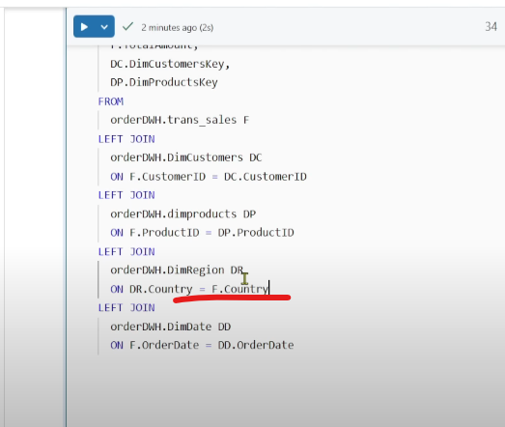  
Note: Joining key should be combination of RegionID, RegionName and Country [Country is most granular column]  
  
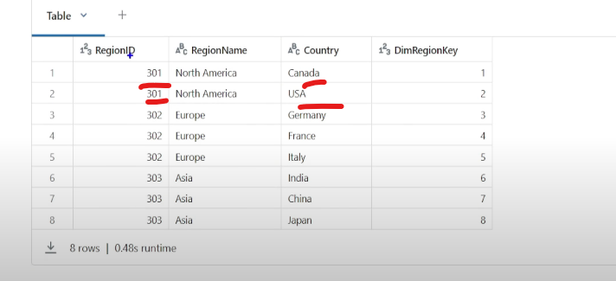For Region, Joining key will be combination of RegionID, RegionName and Country, cause same regionId has different country

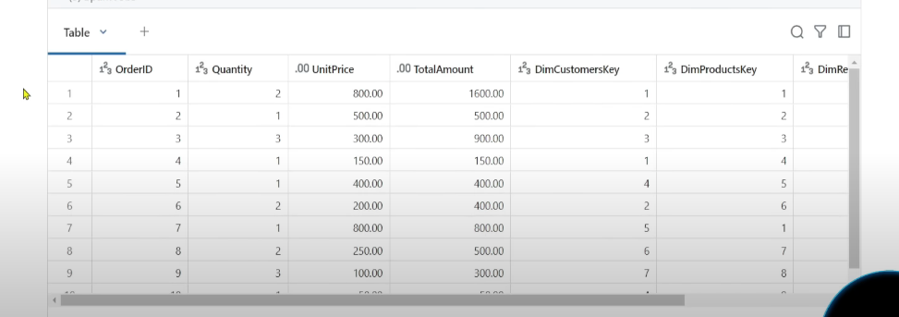

**Types of Fact Table** 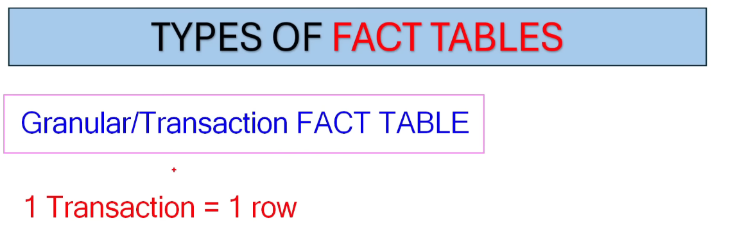 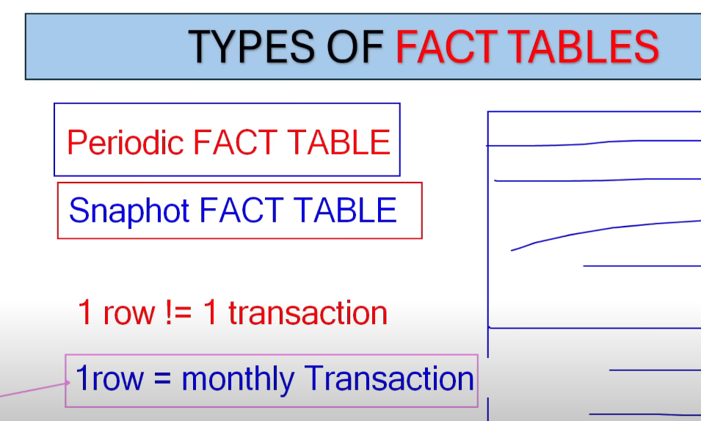  
**1. Granular/Transaction Fact Table:** Most common type, we keep data at the most granular level, we don’t change the granularity of the fact table. 1 transaction = 1 row.  
**2. Periodic Fact Table:** Snapshot fact table🡪1 transaction!= 1 row  
Snapshot of the fact table where aggregation is done on daily/weekly/monthly/yearly and they will define 1 row = many transactions(daily/weekly/monthly/yearly)  
**3. Accumulating Fact Table:** 1 row describes the journey/process. In these types of Fact Tables there will be so many Date columns explaining the entire journey (in Amazon let’s say we have an Accumulating Fact Table containing columns like ordered, orderdate, confirmation_date, seller_info_date, dispatch date, delivered_date)  
  
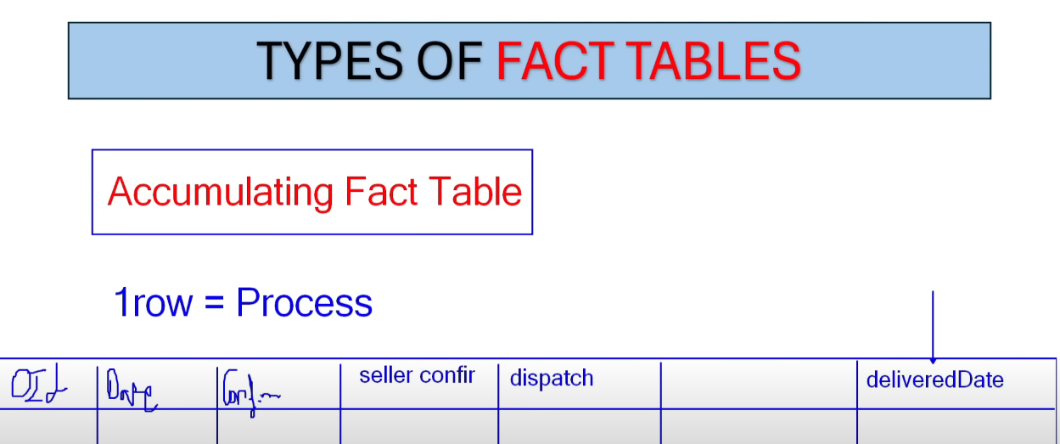  
  
**Types of Dimension Tables**  
1. Conformed Dimension: One dimension is shared with multiple fact tables  
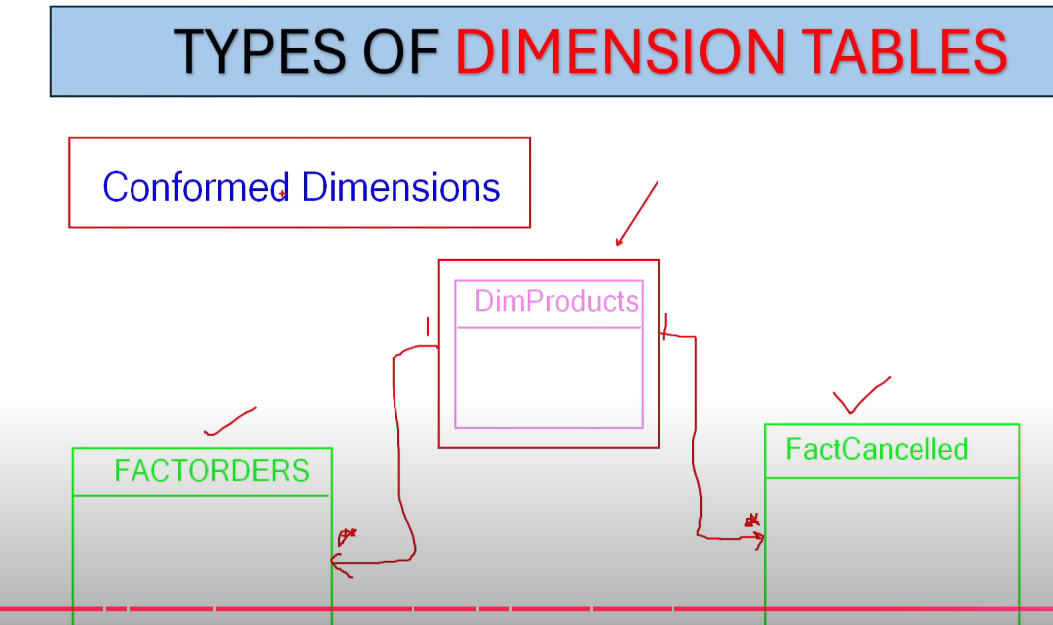

2. Role Playing Dimensions: These dimensions are created when we create Fact table with Dimension table on multiple conditions/relationships 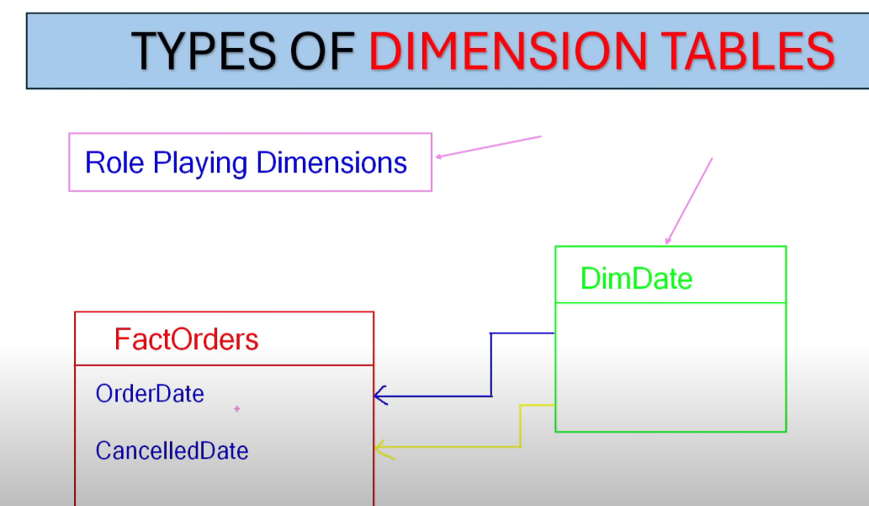  
2 relationships between Fact & dimension, 1 active 1 inactive, the dimension is playing 2 roles, 1 active for OrderDate another inactive for CancelledDate but we can leverage to use the CancelledDate relationship anytime  
  
3. Junk Dimension : Lets say we have a Fact table with columns country & continent, the unique values of country is A and B whereas Continent is X only, so in that case Dimension will only have 2 records, these are Junk dimensions.  
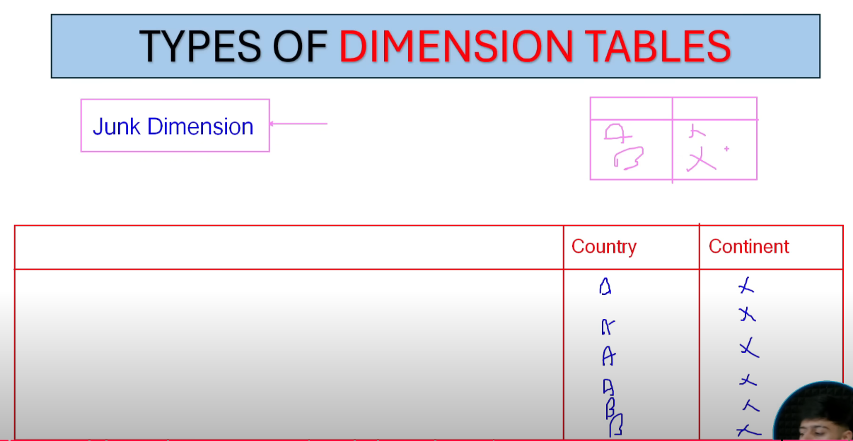

4. Degenerate Dimension : in the Fact lets say we have OrderID column, there is no other contextual value other than OrderID (no Ordername, etc), so if we create a Dimension on top of it, it will have only one column, that is Degenerate Dimension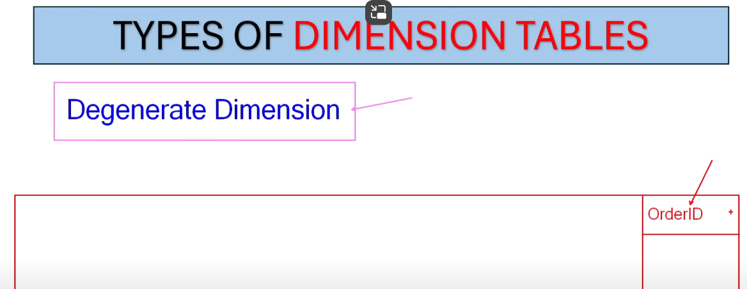  
  
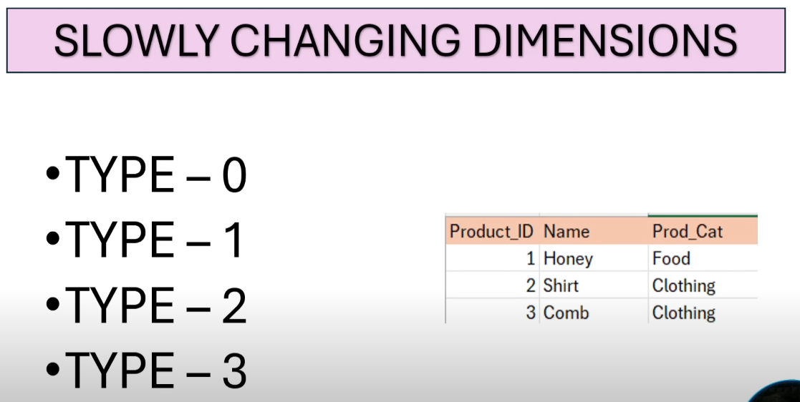  
Type – 0 🡪 No changes  
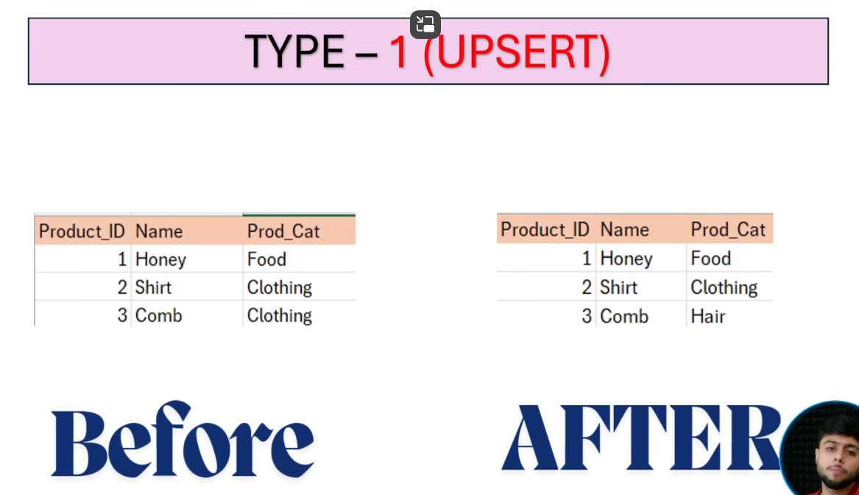  
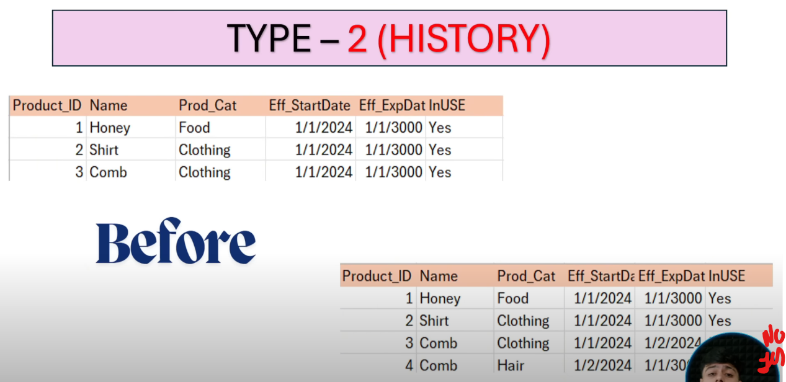 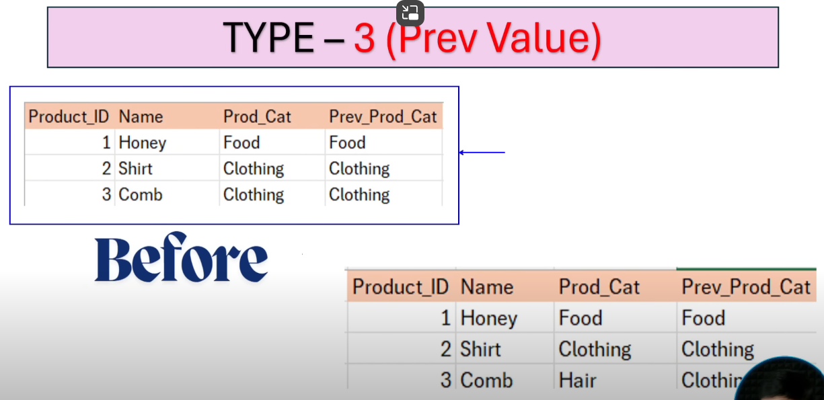   
  
Lets do SCD Type 1  
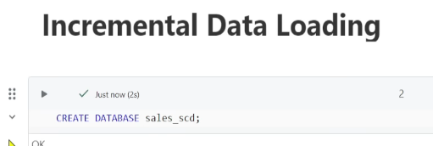 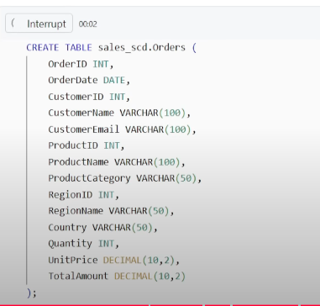  
insert some records  
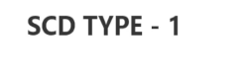Since the table is Fact, lets create a Dimension from this Fact  
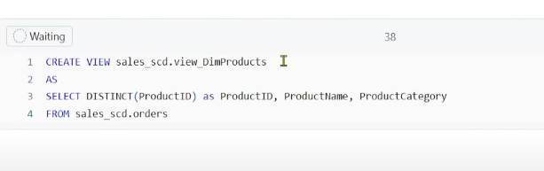 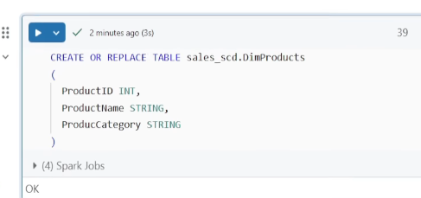 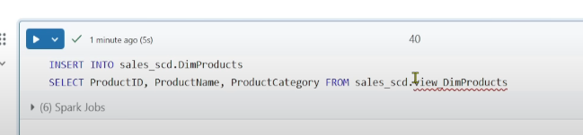  
Now add some data in the source table to check UPSERT logic  
Before that change the view to take care of Incremental Load  
